13TH INTERNATIONAL RUSSIAN-CHINESE CONFERENCE ON DEEP GEOMECHANICS – ADVANCES IN GEOMECHANICS OF HIGHLY COMPRESSED ROCK AND MASSES
Development of Geomechanics of Highly Compressed Rocks and Rock Masses in Russia

V.V. Makarov, professor
Far Eastern Federal University, 10 Ajax Bay, Russky Island, Vladivostok, Russia
M.A. Guzev, director
Institute for Applied Mathematics Far Eastern Branch of Russian Academy of Science, 7 Radio Str., Vladivostok, Russia
V.N. Odintsev, senior researcher
Institute of Comprehensive Exploitation of Mineral Resources RAS, 4 Krukovskii Str., Moscow, Russia

Abstract. A brief overview of the basic principles of geomechanics of highly compressed rocks and masses is presented. The historical path of formation of this new scientific branch of the classical geomechanics is shown. The scales and structural levels of the geomedium failure are identified.
Keywords: geomedium, scale levels, structural levels, continuum model, models parameters.

Geomechanics in the 21st century has become the main scientific discipline, based on the achievements of which it is possible to develop the technology of extracting minerals from great depths, the construction of underground transport and hydraulic structures of large cross-sections, the forecast of the stressed state of the rock mass within the earth's crust, which reduces the risks of catastrophic consequences of geodynamic phenomena of failure of the geomedium.
The intensive development of geomechanics in the 20th century made it possible to combine the rock mechanics and soil mechanics, which contributed to the development of theoretical and experimental methods of these disciplines and to increase the efficiency and safety of the construction of both surface and underground structures. This science has now entered the stage of canonization and the primary solution of purely practical technological problems.
The development of geomechanics made it possible to formulate the idea of a rock mass as a hierarchically block environment (geomedium) in a state far from thermodynamic equilibrium, as well as to develop all the main mechanical models in their application to the solution of practical problems [1].
However, with the accumulation of new knowledge about the patterns of deformation and failure of rocks, classical geomechanical concepts began to come into increasing contradiction with the effects observed in the experiment, such as the zonal failure of the mass around underground mine openings and other nonlinear processes [2]. In addition, the complete inability to reliably predict such phenomena leading to numerous human casualties as rockbursts and earthquakes clearly indicated the need to revise the fundamental principles of geomechanics in its classical form and to form a new scientific direction on its basis.
Over the past 60 years, the development of geomechanics has gone through several stages, the main of which should be considered the creation of ISRM by Leopold Müller in 1962 in connection with the establishment of the block structure of the rock mass [1]. Also, a milestone should be considered the development of "zonal disintegration" phenomenon in the rock mass around deep underground openings by a group of Russian scientists in 1986 [2], which showed all the weaknesses of the existing classical approach to the construction of continuous models of the geomedium. And, third, the development of non-Euclidean models of the geomedium, based on new principles of modeling continuous medium with defects and implemented in relation to the problems of geomechanics by Russian mathematicians in 2000 [3].
L. Müller classified the rock block textures, of rock blocks, especially highlighting the most common "masonry" texture. The disturbance of the rock mass by fracture systems led to a natural weakening of the rock material in the rock massive when compared with the samples. Therefore, he considered the establishment the laws of the difference between the strength of rock masses and the strength of samples as the main goal of creating a scientific community engaged in the development of rock mechanics (ISRM). However, his long-term efforts to implement the task led only to the idea of the discreteness of the structure of the rock mass and the rejection of the application of continuum mechanics to the modeling of the geomedium.
Nevertheless, the concept of rock mass blockiness has acquired the status of a generally accepted one, and the idea of the block structure hierarchy was a further development along this path. In 1979, Academician M.A. Sadovsky came up with such an idea, introducing the term of "rock lumpiness". Further consideration led to the conception of the hierarchy of the rock mass block structure and the determination of the scale coefficient of blockiness from 2 to 5, which gave an average of 3.5.
Modeling of rocks and rock masses during that period was carried out by methods of mechanics of both continuous and discrete medium. To account the fracture disturbance, methods of mechanics of porous and fractured media were used, which believed the properties averaging of the geomedium representative volume The application of these methods showed the presence of one contour zone of the host rock discontinuity for the majority of mine openings and underground structures, the construction of which was carried out in typical conditions for that period at average depths up to 500 meters.

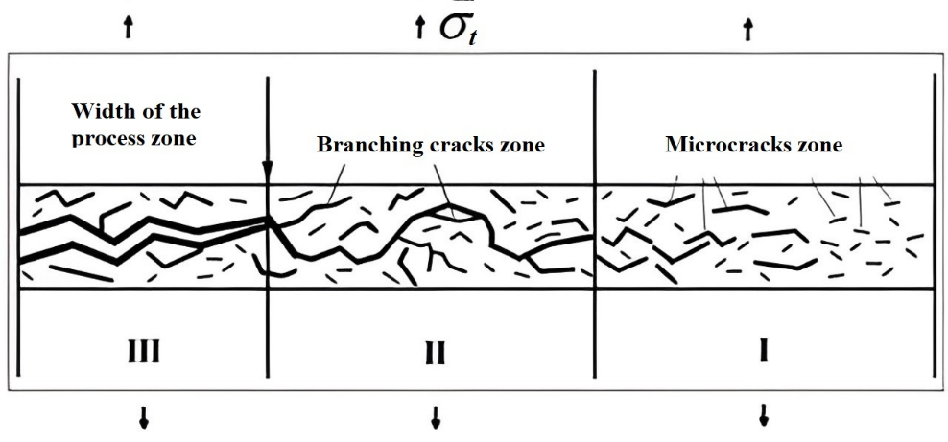
Figure – Diagram for the mechanism of tensile failure during compression (explanation in the text)

In the area of active microfracture (FPZ zone – I), multiple shear microfractures are formed at the grain boundaries. Some of them combine into longer fractures of various orientations, their size can vary from microns to hundreds of microns. The formation of microfractures in a certain volume leads to a local stresses redistribution and connection of microfractures, as a result, an area of destroyed material (zone II) is formed under lateral constraint. This area is actually a "soft dilatating inclusion" that significantly changes the stress state in its vicinity. This inclusion transforms the stresses acting along the fracture into stresses acting in the orthogonal direction. In the linear-elastic approximation, the magnitude of these stresses can be linearly related to the external load acting along the fracture.

References

1) Brown E. T. Fifty years of the ISRM and associated progress in rock mechanics // 12th ISRM Congress October 16–21, 2011 Beijing, China. – ISRM, 2011. – DOI:10.1201/b11646-7.
2) Shemyakin, E. I., Fisenko, G. L., Kurlenya, M. V., Oparin, V. N., Reva, V. N., Glushikhin, F. P., ... & Kuznetsov, Y. S. (1986). Zonal disintegration of rocks around underground openings, Part 1: Data of In Situ Observations. Journal of Mining Science, 22(3), pp.157-168. DOI:10.1007/BF02500863
3) Guzev, M. A., & Paroshin, A. (2001). Non–Euclidean model of the zonal disintegration of rocks around an underground opening. Journal of Applied Mechanics and Technical Physics, 42(1), 131-139.

